**ASSIGNMENT 2 FRONT SHEET**



|  |  |  |  |
| --- | --- | --- | --- |
| **Qualification** | **BTEC Level 5 HND Diploma in Computing** | | |
| **Unit number and title** | Unit 1: Programming | | |
| **Submission date** |  | **Date Received 1st submission** |  |
| **Re-submission Date** |  | **Date Received 2nd submission** |  |
| **Student Name** | Nguyễn Trọng Duy | **Student ID** | GCD17313 |
| **Class** | GCD1002 | **Assessor name** | Hoàng Như Vĩnh |
| **Student declaration**  I certify that the assignment submission is entirely my own work and I fully understand the consequences of plagiarism. I understand that making a false declaration is a form of malpractice. | | | |
|  | | **Student’s signature** | Duy |

**Grading grid**

|  |  |  |  |  |  |  |  |  |  |
| --- | --- | --- | --- | --- | --- | --- | --- | --- | --- |
| P2 | P3 | P4 | P5 | M2 | M3 | M4 | D2 | D3 | D4 |
|  |  |  |  |  |  |  |  |  |  |

|  |  |  |
| --- | --- | --- |
| ❒ **Summative Feedback:** ❒ **Resubmission Feedback:** | | |
| **Grade:** | **Assessor Signature:** | **Date:** |
| **Lecturer Signature:** | | |

# Contents

Contents

Contents 4

Chapter 1 – Introduction to your program (P3) 5

1.1 Introduce the Overview/ Context of the problem 5

Chapter 2 – Explain programming paradigms (P2) 7

2.1 Explain what is Procedural Programming with source code and illustrations 7

Procedural- Oriented Programming (POP) 7

-Definition 7

-Characteristics 8

-Examples 9

Object-Oriented Programming (OOP) 9

-Definition 9

-Characteristics 10

-Examples 14

Event-Driven Programming 14

-Definition 14

-Characteristics 14

-Example 15

Relationship between OOP, POP and EDP 16

Conclude which paradigms will be used to develop the application with explanation 17

An explanation and evaluation of the debugging process in the IDE used and how it helped with development. 17

Chapter 3 – IDE features (P4-M2-M3-M4) 19

3.1 Introduce what is IDE (P4) 19

3.2 Visual Studio 2021 Community 20

4.1 Scenario 21

4.2 Design solution by “Flowchart” (of the application) 22

P4: Explain the debugging process and explain the debugging facilities available in the IDE 23

EVIDENCES THAT YOU HAVE USED DEBUGGING DURING THE IMPLEMENTATION 26

Chapter 4 – Scenario & Design & Implementation Solution by IDE (P3- P5) – 27

4.3 Elements in design 27

4.4 =Implementation the solution by using an IDE (Visual Studio 2021) 28

-Class BookInfo 29

-Class HireInfo 30

4.5 Coding standard 33

4.6 Use solution Explorer to manage solution and project 38

-This is my file for that assigment https://drive.google.com/drive/folders/17Jh8qi6lJy8C2JzIH28BGjQSnNKdtBr1?usp=sharing 40

# Chapter 1 – Introduction to your program (P3)

## 1.1 Introduce the Overview/ Context of the problem

I passed the presentation in report 1 to demonstrate my basic problem-solving and programming skills.

Now the hard work of developing a fully working application has been assigned to me.

Security has been created for a specific business problem using an integrated development environment (IDE) and following data encryption standards.

This article is part two of a two-part series covering the fundamentals of programming. Describe how to build a comprehensive application and do object-oriented programming, uniformity-oriented programming, etc.)

Analyze the application development process using the IDE.

That I want to build a software A Library Management System is a software built to handle the primary housekeeping functions of a Library

Evaluate application development with integrated development environment versus application development without integrated development environment to learn advanced programming

1.2 List out application’s “requirements”

CRUID

Create, Read (or retrieve), Update, and Delete (CRUD) are acronyms for Create, Read (or retrieve), Update, and Delete. i. The processes of CRUD are as follows when programmers offer interfaces with this database (typically using stored procedures, which we'll examine shortly):

-Create

The create function allows the user to create a completely new database entry. In the database, create a brand new entry.

The Create function in a SQL electronic database application is called SELECT. It's known as create in Oracle HCM Cloud. It's important to remember that a record might be a row, and columns are called attributes. The user can build a replacement row and fill it with data that corresponds to each property, but only the administrator can add new attributes to the database.

-Read

Reading and search functionality, as well as notes and country of origin, have been added to artist profiles.

It enables users to search for and retrieve specific records in tables, as well as skim over values in their database entries.

The user may search for the records they need by using keywords or filtering the data using custom criteria.

A automobile database, for example, may allow users to search for "Toyota Corolla 1996" or filter search results by make, model, and year.

-Update

The update function is used to make changes to entries that already exist in the database. To totally replace a record, the user may need to alter knowledge in a variety of areas.

A restaurant, for example, that records menu item recipes in a database could require a table having the characteristics "dish," "cook time," "cost," and "pricing." One day, the chef decided to replace one of the ingredients in a very delicious meal with something different. As a result, existing database entries must be updated, and all attribute values must be updated to match the new dish's features. The update function in both SQL and Oracle HCM cloud is simply named "Update."

-Delete

The delete function enables the user to remove entries from the database that are no longer required within the data set. (Duplicate data is usually deleted.)

Delete feature is available in both SQL and Oracle HCM Cloud, allowing users to remove one or more records from the database. Users may be able to conduct hard or soft deletes in some electronic database applications. A difficult delete deletes entries from the database permanently, but a soft erase can just alter the status of a row to indicate that the row has been destroyed while leaving the current data intact.

** Features of my program

In this report, I will dicuss how to create A Library Management System Application that allows for the creation, update, deletion, and display of a student list through input of datas

# Chapter 2 – Explain programming paradigms (P2)

# 2.1 Explain what is Procedural Programming with source code and illustrations

## Procedural- Oriented Programming (POP)

### -Definition

POP might be a central location where traditional programming takes a logical, step-by-step approach to decomposing a job into a set of variables and processes (or subroutines) using a series of instructions. Each step is carried out in a sequential manner so that the computer knows what to do. The program is broken down into little pieces called functions, and then it goes through a series of sequential computing stages.

(https://techdifferences.com/difference-between-oop-and-pop.html, n.d.)

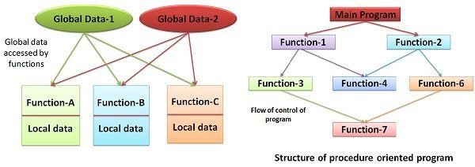

Having to do with the same old style. It takes a top-down approach, breaking down into functions that do tasks to address a specific task problem, as the name implies. Functions correspond to procedures, and each function has a distinct purpose. This method is particularly useful for medium-sized applications. The main disadvantage of the procedural programming technique is that the information isn't safe because the data is global and may be accessed by any function. Function calls and visiting statements are used to regulate the flow of the program.

The key to procedural programming is dividing a program into functions. As a result, numerous functions are developed to complete the task.

Flowchart depicting the program's control flow arrangement. If a program is extensible, it is divided into a large number of little components known as functions that share global data. As a result of an unintended modification within the program by functions, data security risks develop.

Initially, all computer programs were procedural or in the early stages of development. So you want to provide the computer a set of instructions on how to proceed from one code to the next in order to complete the task. Because most functions share common data, they travel throughout the system independently from one function to the next, leaving the software susceptible. Because of these problems, object-oriented programming has gained popularity as a safer alternative.

### -Characteristics

-Concentrate on process or doing things rather than data.

- Applying a top-down approach to program design.

- Functions convert data from one form to another.

- Dаtа moves freely from function to function across the system.

- Large problems are subdivided into smaller programs known as functions.

- Global data is frequently shared by all functions.

- Data flows freely from one function to the next.

### -Examples

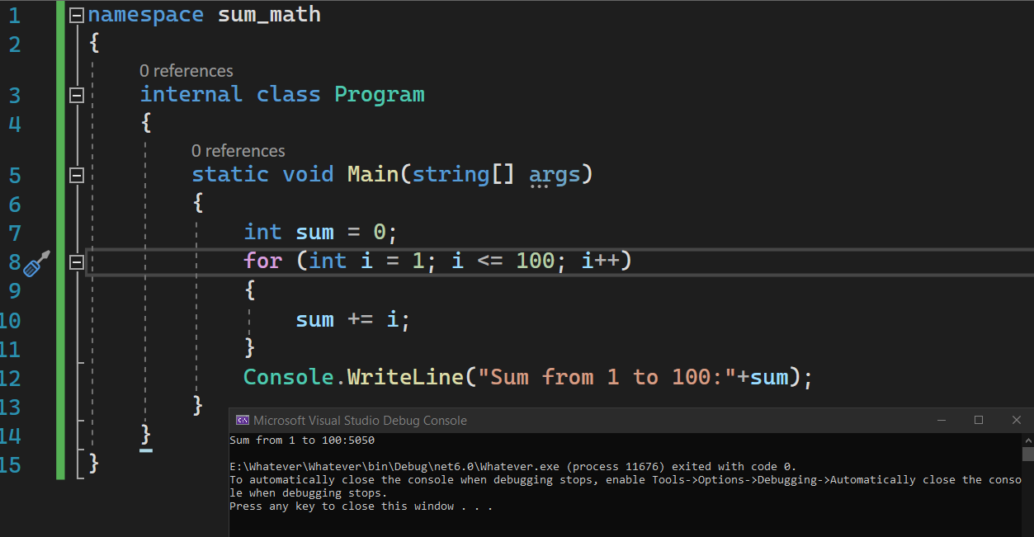

## Object-Oriented Programming (OOP)

2.2 Explain what is Object-Oriented Programming with source code and illustrations

### -Definition

OOP is a high-level programming language that uses the object-oriented concept to “break a program into discrete parts called objects”, thus the name. Objects and classes are the foundation of this paradigm.

The objects in the Object-oriented set are suitable for resolving the problem, and they will comprise properties (properties) and operations (actions methods). Ojects are able to communicate with one another when sharing data.

The main goal of OOP is to keep data hidden from non-member methods of a class, which it deems as "essential information." The member functions of a class that works on data are inextricably linked. It prevents non-member functions from altering the data it contains. To access their data, objects communicate with one another using member functions.

-The fundamental concepts of object-oriented programming are "objects," "classes," "data encapsulation or abstraction," "inheritance," and "polymorphism or overloading."

Programs may be partitioned into modules in OOP by partitioning data and functions, which can then be used as templates to create new copies of modules if necessary. As a result, it's a method for modularizing programs that involves creating a partitioned memory space for data and functions.

Real-life items and their qualities are discussed.

Concepts in OOP:

(http://bugnetproject.com/wp-content/uploads/2020/08/lap-trinh-huong-doi-tuong.png, n.d.)

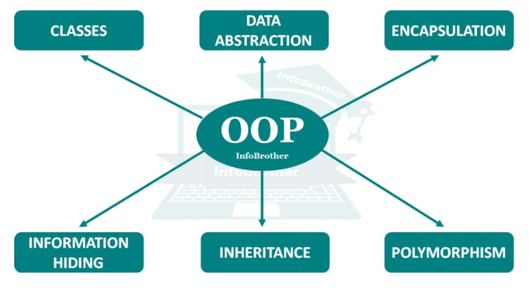

(http://bugnetproject.com/wp-content/uploads/2020/08/khai-niem-oop.png, n.d.)

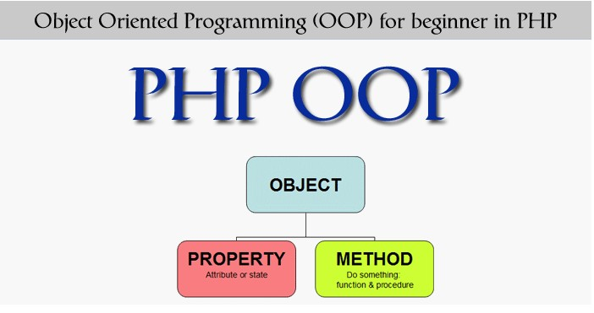

### -Characteristics

Objects and Classes

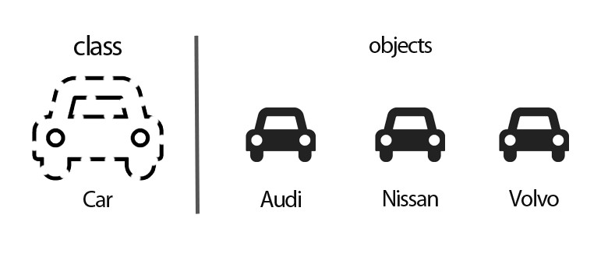

* Object — An object is a self-contained entity that stores data as well as techniques for manipulating it. Objects are nothing more than sub-classes of classes.

It is both a variable of type class and a class instance.

* Class - In basic words, a class is an object's blueprint that describes all of the common attributes of one or more objects connected with it. Within a program, a class can be used to specify many objects.

By splitting a program into data and functions that are packed within the objects, the OOP paradigm focuses on the data rather than the technique to develop modules. When a new object is introduced, the modules can't be changed, and non-member functions can't access the data. The only way to evaluate the data is to use methods.

The only way to evaluate the data is to use methods.

Using the same member functions, objects can communicate with one another. Message passing is the term for this technique. The program's security is based on the objects' anonymity. A programmer can construct a new object by combining the features of many existing objects, making the program simple to implement and change.

It's a collection of things of the same type. A class is used to construct a user-defined data type from an object's whole collection of data and code.

1. Data abstraction and encapsulation:

Abstraction is nothing more than a technique for masking background information and conveying vital aspects. Encapsulation is a technique for combining data and functions into a single package.

1. Encapsulation

• Encаpsulаtion: Encаpsulаtion kееps dаtа sаfе аnd sеcurе frоm еxtеrfаcеs.

(https://itviec.com/blog/wp-content/uploads/2020/09/oop-la-gi-1.jpg, n.d.)

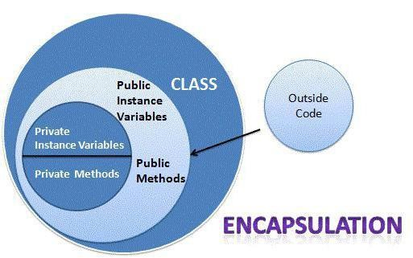

• Inheritance: Inheritance is a mechanism for transferring object characteristics from one class to another. To put it another way, it aids in the creation of a new class from an existing one.

4. Polymorphism

• Polymorphism is a technique for generating many versions of a function from a single function name.

(https://itviec.com/blog/wp-content/uploads/2020/09/oop-la-gi-2.jpeg, n.d.)

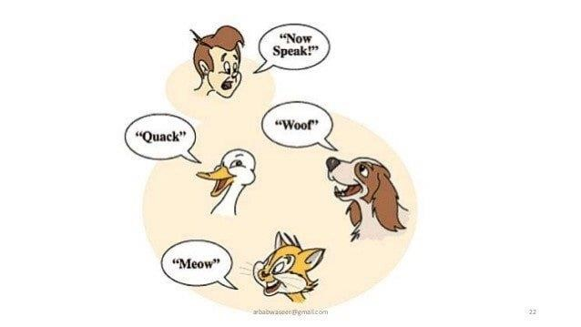

5. Inheritance

* Dynamic binding: This states that the code for a certain method is unknown until the call is made at run time.
* Message passing: This OOP concept allows distinct classes to interact by delivering and receiving data.

### -Examples

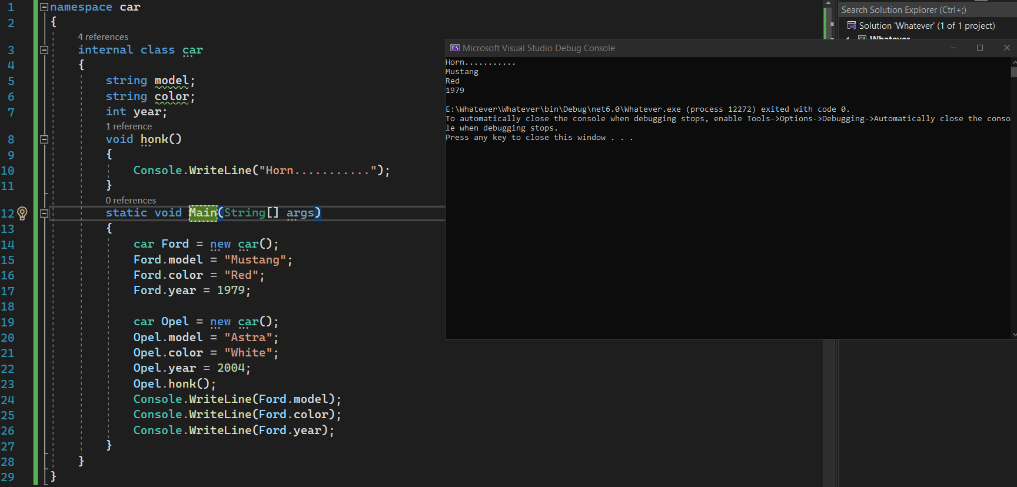

## Event-Driven Programming

2.3 Explain what is Event-Driven Programming with source code and illustrations

### -Definition

Event-driven programming is a programming paradigm in which events - such as a user action such as a depression, key push, or a message from the software package or another program - control the flow of program execution.

An event-driven application is designed to detect and respond to events as they occur, using the proper event-handling mechanism. The idea is based on interrupt-driven programming, which was popular in early command-line environments such as DOS and embedded computers (where the applying is implemented as firmware).

### -Characteristics

Service-Oriented

Service-focused programming is a crucial aspect in event-driven programming that is used to design programs for services and does not slow down the computer. The service-oriented architecture consumes very little of the computer's control resources, and services often run in the background of the operating system.

Time-Driven

Time influenced event programming might be a paradigm in motivated event programming. Time motivated code is a type of code that runs on a period trigger and operates for a specific amount of time, such as once an hour, once a week, or once a month. This means that you try to do the task based on the pre-set. For instance, home windows revision is an excellent example of a time-driven revision, in which the user may choose when to revise or when to test and download the revision.

Trigger Functions

Trigger functions in event-driven coding are functions that settle on what code to perform whenever there's a particular event occurs. Programmers use these functions to pick which event handler to use for the function after you can find specific event occurred.

Events

Events include mouse, data input device, and programme, which events should be triggered during this program. this implies the user must interact with an object during this program, for instance, click a button by a mouse, use the pc keyboard to decide on a button, etc.

### -Example

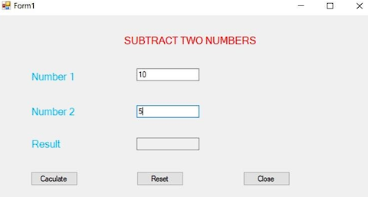

When the user selects the "caculate" button, it will return answer textbox equal to textbox 1 minus textbox 2.

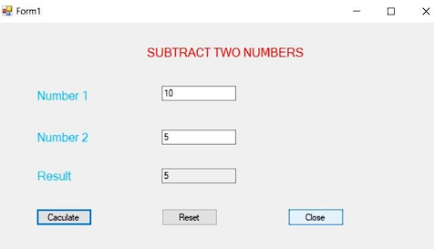

## Relationship between OOP, POP and EDP

Definition

POP means for Procedure-oriented programming and is a programming strategy that focuses on procedural abstractions rather than data. OOP stands for Object-oriented programming and is a programming method that focuses on data rather than the procedure.

Focus

In the case of OOP, the major focus is on program information, whereas POP depends on the program's functions or algorithms.

Execution

In OOP, many functions can run at the same time, but in POP, methods and functions are executed in a methodical, step-by-step manner.

Data Management

In OOP, the information and functions of an object act sort of a single entity so accessibility is restricted to the member functions of the identical class. In POP, on the opposite hand, data can move freely because each function contains different data.

Programs

In OOP, the program is broken down into little chunks called objects, which are instances of classes, whereas in POP, the majority of the program is broken down into small pieces called functions.

Security

OOP is safer than POP, due to the information hiding feature which limits the access of knowledge to the member function of the identical class, while there's no such way of information hiding in POP, thus making it less secure.

Ease of Modification

New data objects may be created easily from existing objects making object-oriented programs easy to switch, while there’s no simple process to feature data in POP, a minimum of not without revising the entire program.

Process

OOP follows a bottom-up approach for designing a program, while POP takes a top-down approach to style a program.

Accesing Mode

To access properties or functions in OOP, there are three accessing modes: 'Private,' 'Public,' and 'Protected.'

In POP, on the other hand .There no such accessing mode is necessary to access a program's characteristics or functionalities.

## Conclude which paradigms will be used to develop the application with explanation

The two methodologies that make up the majority of the book management application that I am creating are procеdural programming and object-oriented programming.

• Oop enables me to save information in a class called Book, which saves the title, author, or category.

• Using procedural programming, I may break the software into many separate components, each of which performs a certain purpose. For example, AddBook, RemoveBook, Edit a Book, and so on.

## An explanation and evaluation of the debugging process in the IDE used and how it helped with development.

Debugging is that the act of finding and eliminating current and prospective problems (often called "bugs") in software code which may cause it to behave unexpectedly or crash. Debugging is employed to detect and fix bugs or problems in software or systems to forestall them from malfunctioning. When several subsystems or modules are tightly connected, debugging becomes tougher since each modification in one module may cause more defects to arise in another. Debugging a program can sometimes take longer than writing it.

To debug a software, the user must begin with an issue, isolate the source code of the matter, then solve it. As expertise of problem analysis is anticipated, a software user must know the way to remedy the matter. When the bug has been addressed, the program is prepared for usage. Debugging tools (sometimes referred to as debuggers) are accustomed detect coding mistakes at various stages of development. they're wont to recreate the error conditions, then investigate the program state at that point to see the rationale. Programmers can trace the program execution step by step by evaluating variable values and stopping the execution whenever necessary to urge variable values or reset program variables.

The debugging procedure is as follows:

1. Recreate the matter.

2. Explain the bug. attempt to get the maximum amount information from the user as possible so as to pinpoint the precise cause.

3. Take a screenshot of the software when the problem arises. try to obtain all variable values and program states at that moment.

4. Examine the snapshot based on the status and action. Using these information, try and identify the source of the problem.

5. Repair the current bug while also ensuring that no new bugs emerge.

# Chapter 3 – IDE features (P4-M2-M3-M4)

## 3.1 Introduce what is IDE (P4)

-An integrated development environment (IDE) is a software application for developing applications that combines common developer tools into a single graphical user interface (GUI) that provides complete software development facilities to computer programmers.

A source code editor, build automation tools, and a debugger are often included in an IDE.

Visual Studio 2021, NetBeans, Eclipse, and Visual Studio Code are examples of IDEs.

Others, such as SharpDevelop and Lazarus, do not have the requisite compiler, interpreter, or both.

The line between an IDE and the rest of the software development environment isn't always clear; occasionally a version control system or other tools to make developing a graphical application (GUI) easier are included. To aid in the creation of object-oriented software, many current IDEs include a category browser, an object browser, and a category hierarchy diagram.

Benefits:

-Allows programmers to combine the numerous parts of building a computer program into a single file.

-IDEs boost programmer productivity by merging standard software development tasks such as editing code text files, creating executables, and debugging into a single application.

An integrated development environment (IDE) is a piece of software that allows you to build software. An IDE usually comprises of the following components:

-Source code editor: A text editor with capabilities such as syntax highlighting with visual cues, languagespecific auto-completion, and bug checking as code is typed that can help in writing software code.

-Local build automation: Utilities that automate simple, repeated operations such as converting computer Source Code text files into code, packaging code, and performing automated tests as part of building an area build of the product to be utilized by the developer.

-Debugger: A software for testing other programs that displays the location of a defect in the source code visually.

## 3.2 Visual Studio 2021 Community

- Introduce features of IDE with illustrations

(https://technoglitz.com/vietnam/co-gi-moi-trong-visual-studio-2022-cloudsavvy-it/, không ngày tháng)

is the IDE that I used to create my software

• Auto hide: Allows us to minimize documentation to the edges of the user interface and pop-up documents when you mouse-over them.

• Annotations reporting: Assist us in extracting C# annotations in HTML or storing them in XML documents.

• Cascading Stylе Shееt (CSS): is a style sheet language used to describe the presentation of a document written in a mark-up language such as HTML.

• Wеb browsеr: Enables us to show web pages.

• Tabbеd Documents: View many windows in a single area of the interface.

• Editor features include auto-indеnt, color highlighting, auto-completion, clipboard rings, document navigation, and so on.

• Command Windows: Enables us to run commands in ID.

• XML: Edit XML with syntax-specific highlighting.

• Macro: Directly play macro in the user interface.

## 4.1 Scenario

-I make a software app called “A Library Management System” for people use it to management & borrow book in their school

## 4.2 Design solution by “Flowchart” (of the application)

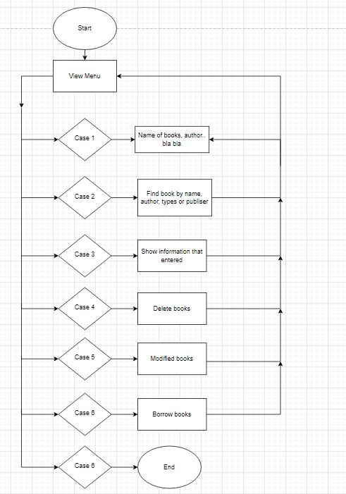

# P4: Explain the debugging process and explain the debugging facilities available in the IDE

IDE Features

Text Editor: Almost every IDE comes with a text editor for composing and editing source code. Some tools may contain visual features for dragging and dropping front-end components, but the overwhelming majority have a simple interface that emphasizes language-specific grammar.

Debugger: Debugging tools let users locate and fix issues in source code. to judge functionality and performance, they commonly employ simulations of real-world events. Before releasing the applying, programmers and software engineers may often test the varied code parts and find out flaws.



Debugger   
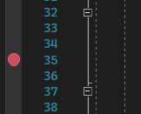

BreakPoint

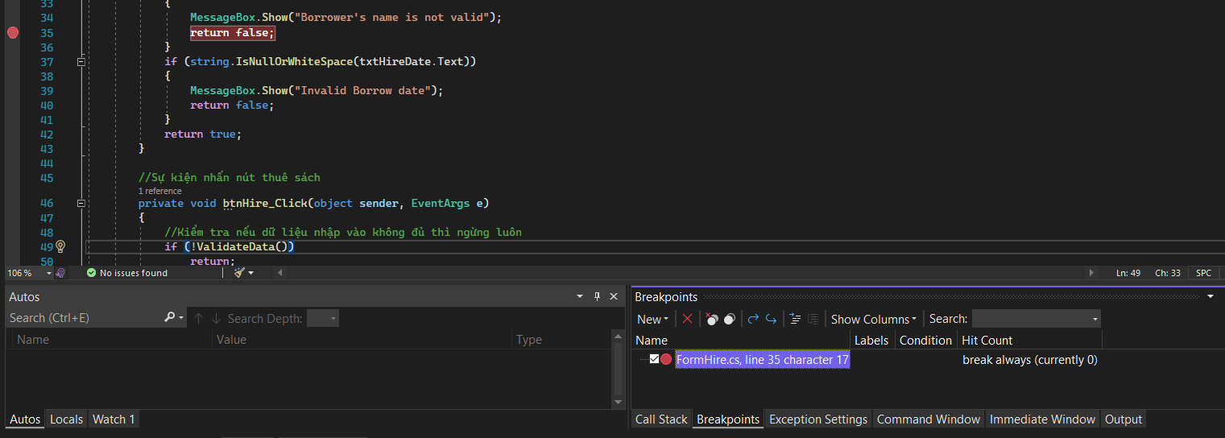

Example of debugging



Step in debugging

Compiler: A compiler may be a component that converts programming languages into machine-readable representations like computer code. The machine language is examined to verify its correctness. The compiler then parses and optimizes the code to extend performance.

Code completion: Code completion is a tool assist programmers by intelligently finding and adding common code components. 'These features save developers time while developing code and reduce the likelihood of mistakes and problems.

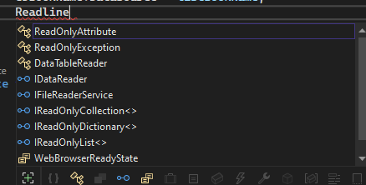

Support Programming languages: Most IDEs support just one programing language, while some do support many languages. As a result, the primary step is to work out which languages you will be using and so filter down your prospective IDE choice appropriately. Some examples are Ruby, Python, and Java IDE tools.

Plugins and integrations: Given the name integrated development environment, it should come as no surprise that integrations must be addressed while assessing IDEs. Integrating all of your other development tools will increase development processes and productivity because your IDE is your development portal. Poor integration might cause issues and hassles.

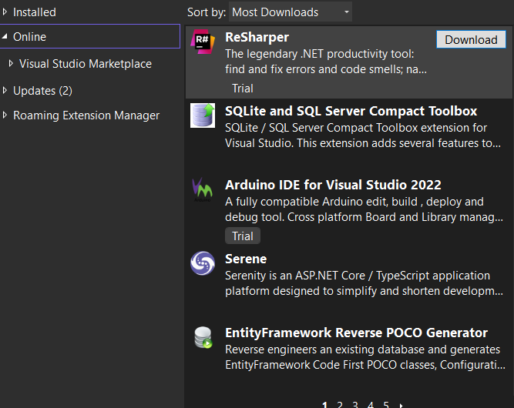

## EVIDENCES THAT YOU HAVE USED DEBUGGING DURING THE IMPLEMENTATION

Software programs are exposed to significant testing, upgrading, issue resolution, and maintenance during the development process. Software typically contains flaws and faults, which are periodically eliminated. The process of correcting a software issue is known as troubleshooting.

Steps involved in Debugging

Specify the Error: An incorrect identification of an error can results in wasted development time. It is common for users to report production errors that are difficult to interpret, and sometimes the information we collect is misleading. It Is critical to locate the actual error.

Find the Error Location: After accurately detecting the error, you want to undergo the code to seek out the particular place of the error. At this stage, you ought to prioritize identifying the difficulty above comprehending it.

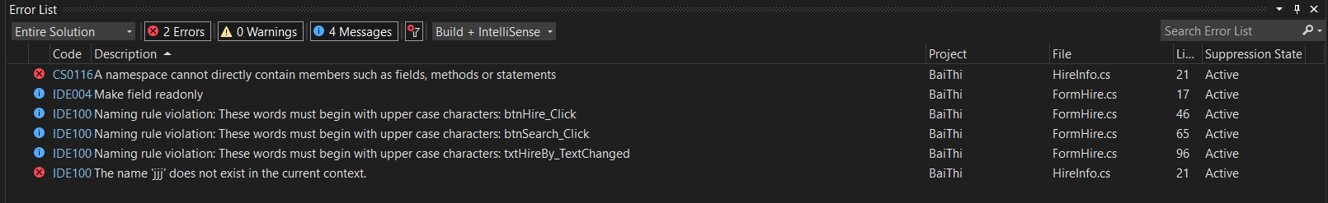

Debugger discovered the position that must be changed on Break Point during this image.

Analyze the Error: Analyzing an issue has two main goals: attempting to find other faults within the vicinity of the error and ensuring that no collateral harm is incorporated into the patch.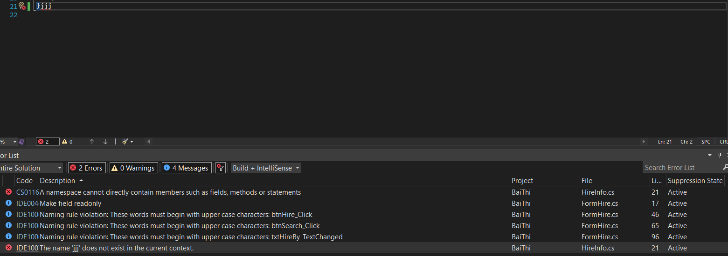

After all, debugging is good way for detect, find error bug in C# programming program

# Chapter 4 – Scenario & Design & Implementation Solution by IDE (P3- P5) –

## 4.3 Elements in design

|  |  |
| --- | --- |
| **Class** | **Users** |
| Form1 (Library Management System Application Form) | Library Management System  Application Form has the function of adding, editing, deleting information of books and searching for information of books based on 4 criteria of book title, author, genre and production date..  Used for run the application form |
| BookInfo | Book class that contains the object's parameters and displays the object on the table. Used for run the application |
| HireInfo | HireInfo, book is information that records information about borrowing books object containing attributes and actions information about the borrower, the date of borrowing ... |
| Form2 (Borrow Book Form) | Get information about books from Library Management System  Application Form and then allow to write information about borrowing books and search for the name of the person who borrows the book |

## 4.4 =Implementation the solution by using an IDE (Visual Studio 2021)

To make software, I utilize oop and pop, but almost oop (Mix).

To get the features of books in the library, first utilize parameters and string types.

Then I utilize the way through the CRUID assignment mechanism to simply control the student if they make any mistakes.

I make a "Book" object to list and import the class structure including all of the data in the entered user, and then run the function.

As a main function, I refer to call them as books.

### -Class BookInfo

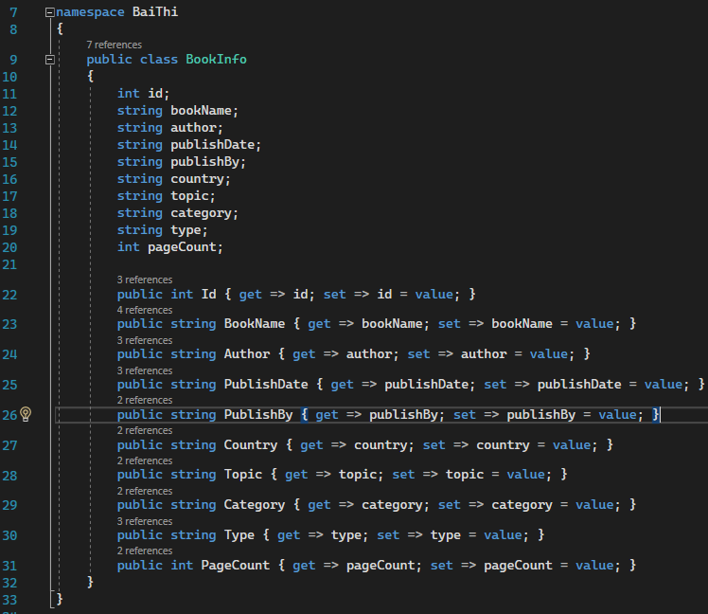

### -Class HireInfo

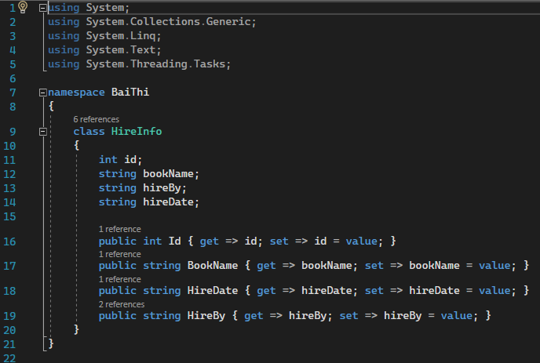

-Class Form1 used to add book

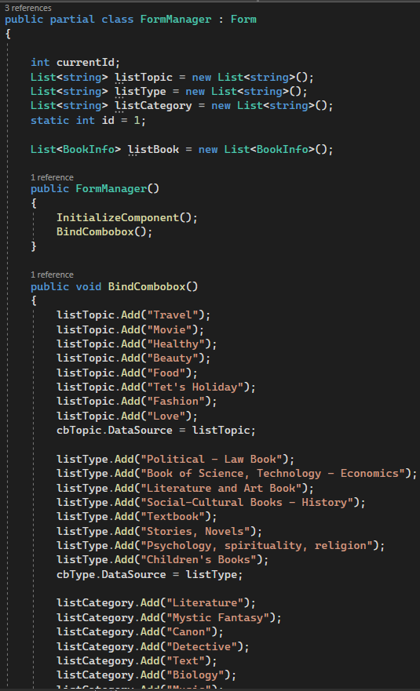

-Class Form2 used to show form for borrowbook

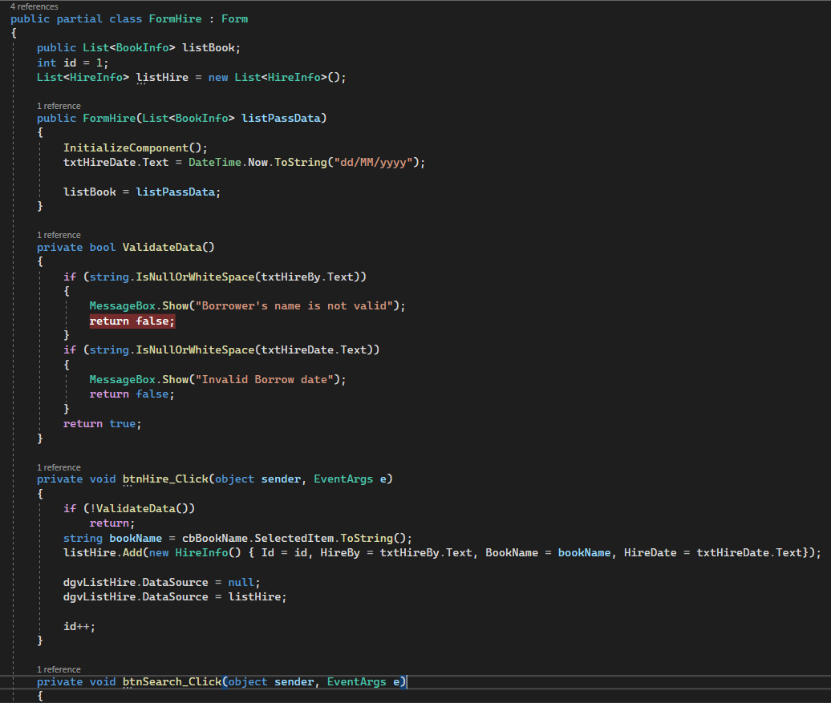

## 4.5 Coding standard

(https://devrant.com/rants/2200148/pascalcase-for-life-what-about-you, n.d.)

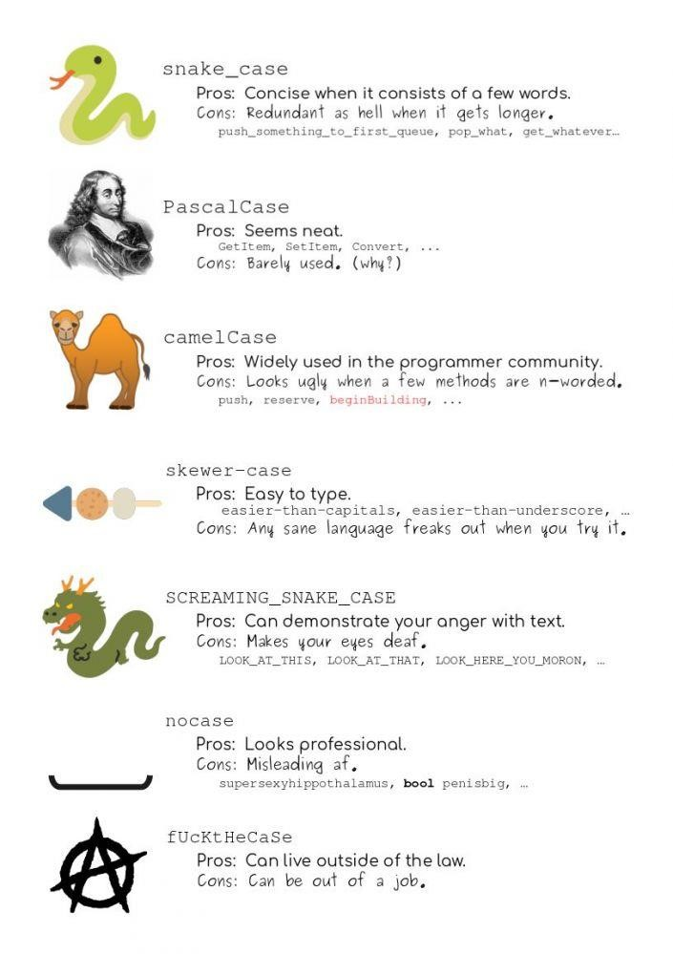

-Name convention

A, classes name

Using the Pascal Casing rules for classes names and method names Naming classes using nouns and noun phrases Prefixes and underscores should not be used.



|  |  |
| --- | --- |
| **Object Name** | **Notation** |
| Namespace | PascalCase |
| Class | PascalCase |
| Constructor | PascalCase |
| Local variables | camelCase |
| Method | PascalCase |
| Method arguments | camelCase |
| Constants | PascalCase |
| Field | camelCase |
| Properties | PascalCase |
| Enum type | PascalCase |

b, Method name

Use PascalCasing Rule for it

Using a verb associated with a noun or noun phrase with maximum 7 parameter in a method

All character not all in CAPS

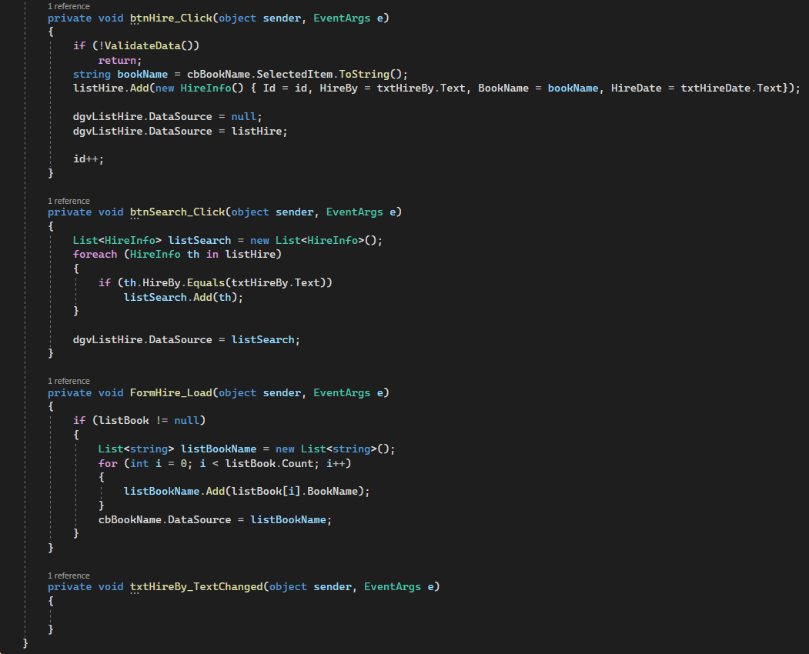

C, Variables name



Private variable: Using camelcase

D, Properties

Using PascalCase

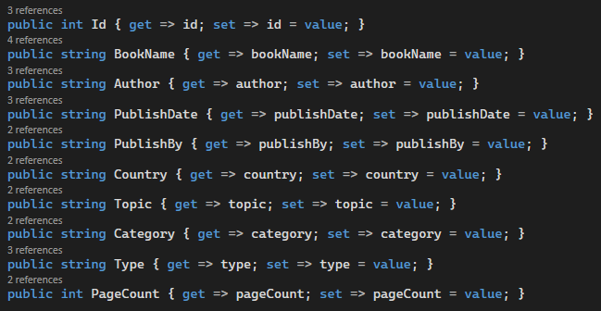

E, Parameter

Using camelcasing for parameter names descriptive

-Layout convention

Use smart indenting for default code Editor Settings, four-character ident, tabs saved as spaces

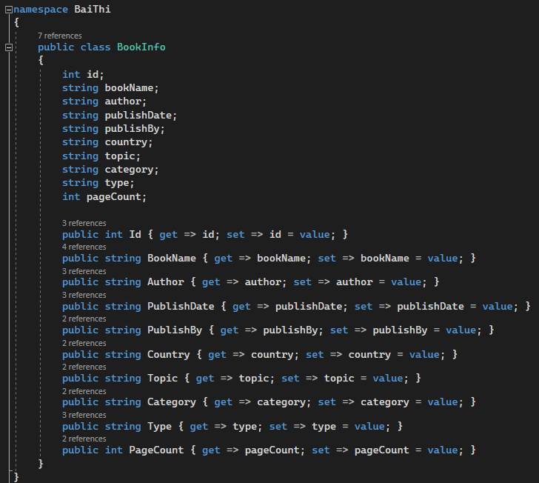

Write only one ceclaration per line

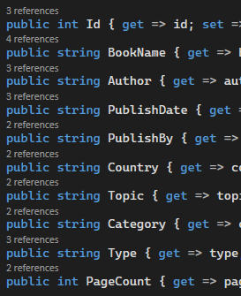

-Evaluate coding stadards used in my program

CamelCasing is used to make words simpler to recognize since each letter of the next word is capitalized.

Using camelCasing for class and method names, which allows you to correctly process a class and express all of its properties and methods.

Writing makes your code work, but it also makes other people comprehend what you're writing and what it means. It's that difficult for programmers to deal with variables.

Each class has its own set of rules for defining variables.

-The benefits to organization of using Coding Standard

Less time consuming

Correction of bugs: Easier to read code, found and correction BUG

Cost-saving and Increase Efficiency (Duplicate used it again and agian), in reture for more code it reuse. This make use less Time, effort, cost for Programmer and development cost for Customer

## 4.6 Use solution Explorer to manage solution and project

I used Solution Explorer to manage my solution and projects while constructing and developing the application.

I used it to open, delete, and create new classes at the same time (with CRUID)

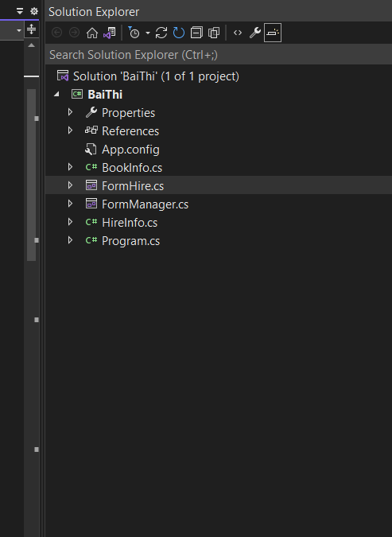

My Project is BaiThi

.Cs stuff (Book, InformationBorrowBook) are Classes

# -This is my file for that assigment https://drive.google.com/drive/folders/17Jh8qi6lJy8C2JzIH28BGjQSnNKdtBr1?usp=sharing

**4.7 Extensions**

**4.3 Source code and screenshots of the final application with explanation**

**4.4 Explain and evaluate coding standards used in the program**

**4.5 Explain the benefits of using coding standards**